- Connect cables to power supplies
  - 3x 4139 cables, 1x 4163 cable
- Connect 2 HMC sig gens
- Connect the RF connections as follows in the diagram
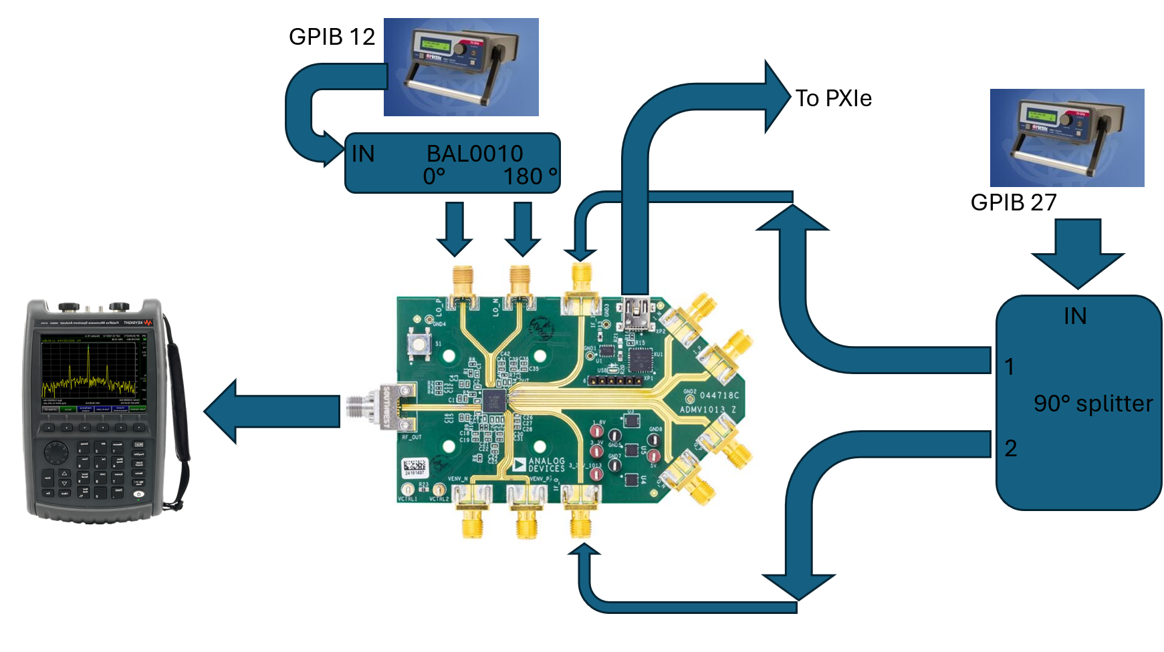

- Connect the banana jacks as follows
- Be sure to connect all ground connections together. There should be one for each card and the DUT ground (3x 4139, 1x DUT).
Black GND | GND connections
Red 5v | 4 VCC (4139 card)
Orange 3.3 | 5 VCC (4139 card)
Yellow 1.8v | 6 VCC (4139 card)
- Open the Labview software
  - Configure the Data block as necessary
- Open the power block
Be sure to activate all channels and queue the changes
  - Slot_4
    - Voltage = 5v, channel name = Red 5v
  - Slot_5
    - Voltage = 3.3v, channel name = Orange 3.3v
  - Slot_6
    - Voltage = 1.8v, channel name = Yellow 1.8v
- Open the RF Block
  - GPIB 27
    - Name = IF, Freq = 1GHz, Power = +10dBm,
  - GPIB 12
    - Name = LO, Freq = 6.5GHz, Power = 0dBm
- Check unconfigured Supply Currents
- Note! If the part is pre-configured this could be different, see the configured supply currents if this doesn’t match.
Red 5v | Orange 3.3v | Yellow 1.8v
~20mA | ~380mA | ~3mA

- Open part in ACE. Confirm that the VCTRL voltage will be 1800mV, this is the default value so there should be nothing necessary to do here. Ensure that the block diagram is in its default state, shown below
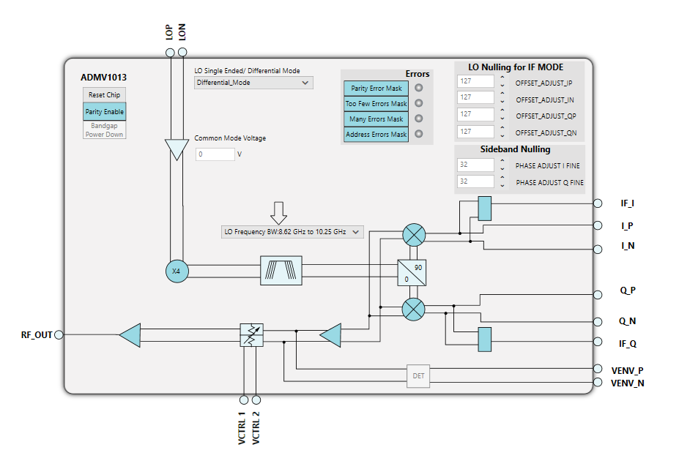

- Note the configured Supply Currents
Red 5v | Orange 3.3v | Yellow 1.8v
~20mA | ~380mA (555 w/ vctrl @1.8) | ~2mA
- Ensure a tone is visible at 25/27 GHz, should be around -21dBm
- Open the python script at the file path C:\Git\Rad-Effects-Test-Software\Python Scripts\ADMV
- Run the python script and click record data toggle in labview

